**TTCPay**

   
 

**Submitted By:** Team 3

**Submitted To:** Hao Lac

ICET Department,

**School of Engineering Technology and Applied Science**

Progress Campus, Block A

Centennial College

**Discipline:** Software Engineering 

**Due Date:** September 23, 2018

# Declaration of Sole Authorship

We, Team 3, confirm that this work submitted for assessment is our own and is expressed in our own words. Any uses made within it of the works of any other author, in any form (ideas, equations, figures, texts, tables, programs), are properly acknowledged at the point of use. A list of the references used is included.

**Signed:**

1. Manthan Shah (300990910)
2. Sakshi Bharti (300991470)
3. Sidharth Choudhary (300990285)
4. Sahith Reddy Gudipati(300986770)
5. Shiva Bhalla (300985590)
6. Kiranpreet Kaur(300989437)
7. Deepinder Kaur(300990268)
8. Gurpreet Kaur (300989390)

**Date:** September 23, 2018

# Abstract

The traditional way of buying tickets in TTC possesses numerous problems and to overcome such problems our team has identified a solution which will help people to buy TTC tickets and passes on their smartphones..

In this technical report we explore the methods which are currently used and built an application which will allow the user to register oneself, purchase and activate a TTC ticket or a pass containing a bar code which can further be scanned by the drivers. We provide a flexible, easy and a convenient way to travel on TTC buses.

This project holds a great significance to the Toronto transit riders who commute daily by buses and streetcars. Losing paper tickets, waiting in long queues to buy monthly bus passes, shortage of coins while paying the fare and many other such issues are faced by people on daily basis.

**Table of Contents**

**Declaration of Sole Authorship** **2**

**Abstract** **3**

**List of Figures** **6**

**List of Tables** **7**

**1.0 INTRODUCTION** **9**

**2.0 METHODOLOGY AND RESULTS** **11**

2.1 Literature Review 11

2.2 Proposed Solution 11

2.3 USER ROLE MODELLING 14

2.3.1 Brainstorm and Group 14

2.3.2 Consolidated User Roles 15

2.3.3 Description of User Roles and Persona 16

2.4 Release 1.0 18

2.4.1  User Stories 18

2.4.2  Additional Documentation 28

2.4.5  Progress Monitoring (Iteration 1 & 2) 34

2.4.6 Acceptance tests 35

2.5 Release Plan 37

2 2.5.1 User Stories 37

2.5.2 Release Plan 2.0 39

2.5.3 Iteration Plan 41

2.5.4 Additional Documentation 43

2.5.5 Progress Monitoring 43

2.5.6 Acceptance tests 43

1.0 Introduction 50

1.0.1   Goals 51

1.0.2   Risks And Assets 51

Describe the elements that might positively influence testing on the project. 51

2.0 Scope 51

2.0.1   Features To Be Tested 51

3.0 Testing Procedures 52

3.0.1   Test Objectives 52

3.0.2   Types Of Testing 53

3.0.2.1   Unit Testing 53

3.0.2.2   Integration Testing 53

3.0.2.3   Acceptance Testing 54

3.0.2.4   Stress Testing 54

Our application must be able to run on an android platform with android version 4.4 or above. 54

4.0 Schedule and Deliverables 54

# List of Figures

Figure 1: Network Diagram. 12

Figure 2: Organizing the user role cards on a table 13

Figure 3: The consolidated role cards 14

Figure 4: A “consolidated” low-fidelity prototype for passenger 17

Figure 5: Low fidelity prototype for admin 19

Figure 6: A low-fidelity prototype for manager 20

Figure 2.4.1: Representation of login story card. 21

Figure 2.4.2: Representation of ticket purchasing story card. 21

Figure 2.4.3: Representation of choosing a ticket category story card. 22

Figure 2.4.4: Representation of introducing changes by admin story card. 22

Figure 2.4.5: Representation of posting advertisements by manager story card.23

Figure 2.4.6: Representation of activating purchased ticket/pass story card. 23

Figure 2.4.7: Representation of Payment Method story card. 24

Figure 2.4.8: Representation of viewing ticket history story card. 24

Figure 2.4.9: Representation of concurrent users access story card. 25

Figure 2.4.10: Representation of pre-estimation of the journey story card. 25

Figure 2.4.11: Representation of termination of the ticket story card. 25

Figure 2.4.12: Representation of purchasing a pass story card. 26

Figure 2.4.13: Representation of making a payment story card. 26

Figure 2.4.14: Representation of selecting pass type story card. 27

Figure 2.5.1: Representation of Feedback story card. 38

Figure 2.5.2 Representation of ticket expiration story card. 38

Figure 2.5.3 Representation of editing/deleting the profile story card. 39

Figure 2.5.4: Representation of changing/selecting language story card. 39

Figure 2.5.5: Representation of notifications regarding promotions story card 39

# List of Tables

Table 1: The Must-Have stories for Release 1.0 25

Table 2: The Should-Have stories for Release 1.0 25

Table 3: The Could-Have stories for Release 1.0 31

Table 4: The Wont -have stories for Release 1.0. 31

Table 5: Release plan Table 32

Table 6: Disaggregated tasks per menu accessing story 37

Table 7: Disaggregated tasks per buy ticket story 37

Table 8: Disaggregated tasks per buy a pass story 38

Table 9: Disaggregated tasks per choose ticket category 38

Table 10: Disaggregated tasks per selection of type of pass story. 39

Table 11: Disaggregated tasks per login story 3

Table 12:Disaggregated tasks per payment story 32

Table 13:Disaggregated tasks per ticket activation story. 32

Table 14:Disaggregated tasks per add/edit or delete the debit credit card details . 32

Table 15:Disaggregated tasks of addition of a credit/debit card story 33

Table 16:Disaggregated tasks of view ticket history story 34

Table 17:Release plan 2 stories list 39

Table 18:The Must-Have stories for initial Release (2.0). 39

Table 19:The Should-Have stories added to Release (2.0). 39

Table 20 : The Could-Have stories 40

Table 21:Release 2.0 plan Table 40

Table 22:Disaggregated tasks of admin login story 41

Table 23:Disaggregated tasks of admin can access users & tickets story 42

Table 24:Disaggregated tasks of feedback story 42

Table 25 Disaggregated tasks of admin can make changes story 43

Table 26 Disaggregated tasks of editing and deleting profile information story 43

Table 27:Disaggregated tasks of notifying User for Pass expiration information story 43

Table 28:Progress and changes for all Iterations for Release 2.0 44

Table 29: Acceptance tests for Release 2.0 45

:

# 1.0 INTRODUCTION

People in day to day life use TTC buses to travel for their business, schools etc. TTC buses take people almost anywhere they want to go very quickly in Toronto. But most of the people facing problems to manage TTC fare while travelling. TTC offers paper tickets, tokens and PRESTO as valid ticketing proof. While boarding to bus sometimes people forgot to buy tickets and then they have to purchase ticket from driver by putting coins in box. And at that area they face a big problem as no change/ coins available.

Furthermore, if they purchase those tickets they have a fear to loss paper tickets issued by driver for next two hours.

To overcome this issue, our team proposes a solution to develop an android application named as “TTCPay” where people can buy digital tickets and passes. This app will allow users to check their ticket history, buy tickets online and leaving behind the hustle of carrying coins to pay the fare while boarding. By using this application, people have no need to carry PRESTO card or paper-ticket with themselves while travelling as ticket with hour limit(running clock) would be available on application. Also there would be a BAR code reader with mode information of ticket.

If we talk about the technical aspect of problem, we could say it is so hard for both driver and passenger to manage the paper ticket. Sometimes, paper is not available on machine and passenger has to wait for long time, which further delays the bus. Also for PRESTO users, if the PRESTO machine on bus has some technical problem, then driver has to allow that passenger to board bus for free, which leads to business loss. According to recent Toronto Star report, The TTC has inadvertently given out 1.4 million free rides over the past two years because of faulty technology.

The problem described above is very general problem that we as a student are facing now a days. Although a lot of students have their monthly passes to travel. Still if for one or two days their passes has expired then they have to go to TTC station to buy a new one. Our proposed solution is providing a better way not to waste time by going to station to buy new passes as application provides a better way to buy a paperless monthly pass via phone. Team chose this project to resolve people's daily life problem by saving their time and money.

Every person travel on regular basis for different purposes. This daily travelling is going to cost you by time anyhow. So, we come up with an idea of this application which allows passengers to buy TTC tickets and passes anytime through their smartphones. This is a flexible and convenient way of purchasing tickets. Moreover, it will help users to search routes, address and stop numbers and find specific stop details.

Our objective to provide an optimal solution for the problem encountered above. Our main focus is to save people time and money and make their travelling easy and relaxed. By offering this application as a solution, people no need to worry about tickets, passes and coin money. They can directly buy tickets or passes from this application and can show to the drivers while boarding the bus. The additional feature to check the ticket history and pre purchase of tickets provide more flexibility and features for people.

The real time problem our team face to interpreting the work is to find out How TTC works. To deeply understand the problem we need to contact people of different categories who use TTC for daily travelling and find out how paying with various methods affect their time and money. The another big problem we face as a team to find out the perfect solution for the problem. We as a group of two, travel to different TTC routes with different payment methods to find out the problem. It was so tedious task for us while managing studies and other stuff at same time.

# 2.0 METHODOLOGY AND RESULTS

## 2.1 Literature Review

The problems that are faced by TTC were tried to get solved by the students mainly focusing on the aging infrastructure, challenges of the budgets, customer complaints, and many more. Many solutions were implemented but no desired result was obtained as per the expectations.

Secondly, the solutions regarding the sexual harassment and assaults were to be taken care of because of which the citizens were suffering a lot. But, there was no such proper conclusion given for these problem too.

Besides these, we are facing many problems such as presto card, no-change issues, absence of coins, losing the paper tickets or the monthly bus passes, etc. Moreover, many newly arrived people are not aware of the expiration of the ticket that it gets expired in two hours from the time of issue. So, to overcome such problems, we are developing an app through which the work of the citizens will become too easy.

The app will act as a helping hand to the people as buying tickets online, ticket history, change issues will be solved. And, furthermore, people can also pre-purchase the tickets prior to their boarding to prevent the hustle at the station. Once registered as a passenger, a person can solve these tickets and passes issues easily.

## 2.2 Proposed Solution

TTCPay application will allow customers to book their tickets online and will provide them digital tickets and passes which they can activate when they will start their journey. Moreover, people will get the feature of checking their ticket history. This app will be more convenient for people as they don't have to worry about losing their paper tickets or having change (coins, bills) all the time for ticket and they can book their ticket in advance. E-ticket is a better option than a paper ticket as their will be a unique barcode with ticket information on every ticket so it will be easy for drivers or ticket checkers to scan barcode and verify the ticket.

**Strengths of TTCPay:**

1. Digital ticket will be provided, so no fear to lose the ticket.
2. Pre-purchasing of ticket.
3. People can activate their ticket any time before the starting of their journey**.**
4. All information will be printed on the ticket such as validity of ticket or ticket expiration.
5. People can check their ticket history and can check that how much they spend monthly on their travelling.
6. Discounts will be provided based on their ticket and passes booking history.
7. Easy to use and fast service.

**Weaknesses of TTCPay:**

1. Need of internet connection all the time
2. Need good battery backup for device
3. Should know how to use android app in phone

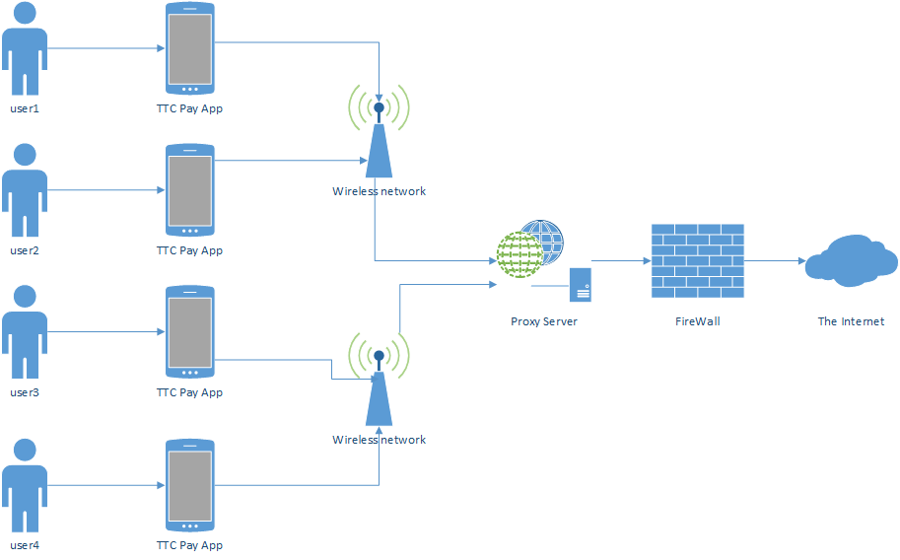

Figure 1 Network Diagram

## 2.3 USER ROLE MODELLING

### 2.3.1 Brainstorm and Group

After a collaborative discussion by our team members on brainstorming of user roles, our team concluded on the user roles stated below.

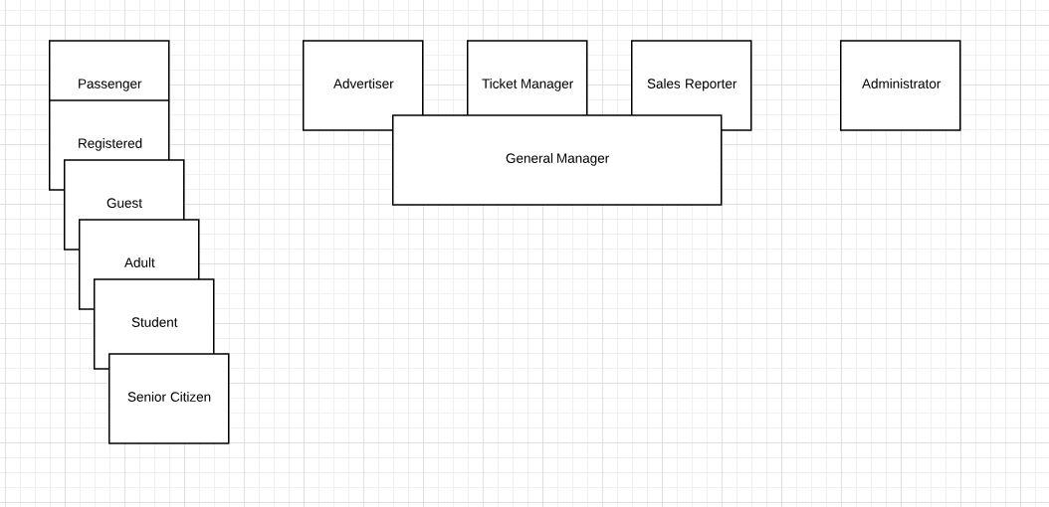

Figure 2: Organizing the user role cards on a table [1].

### 2.3.2 Consolidated User Roles

After a brief discussion on the user roles , our team tried to consolidate and condense the roles.The figure below shows the consolidated roles for the TTC Pay app :

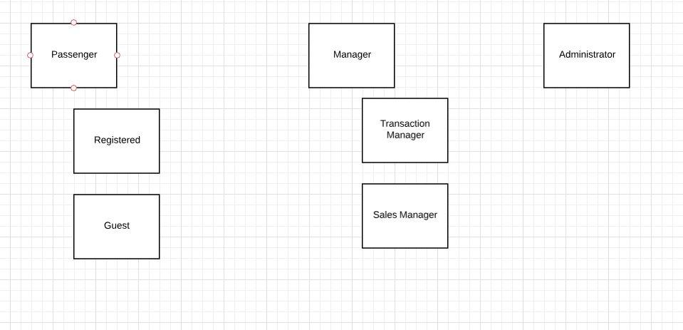

Figure 3: The consolidated role cards [1].

### 2.3.3 Description of User Roles and Persona

All of the consolidated user roles with their brief role description is as below:

a. **Passenger:** This person plays a role of main user who will access this application on frequent basis. This role could further be of two types: Guest User or Registered User. Based on the selection to use application, passenger can perform certain activities offered.

* **Registered user:** Registered user will enjoy the benefits of viewing all the discounts and promotions, view transaction and travel history and will be able to purchase tickets at discounted rates.
* **Guest user:** Guest user will be a regular user who will be able to purchase a ticket at a normal price without having access to the discounts and promotional offers and would not be able to view his travel history.

b. **Administrator:** The core function of any software is to administer it. Administrator is the user role who will perform administrative tasks like managing the software users, tickets, performance etc. This user role will be the second main role who will  
frequently use application.

c. **Manager:** The role of the manager is to handle the reports of purchasing details of individual users. The role of manager is further divided into two categories: Transaction manager and sales manager.

* **Transaction manager:** Transaction manager will be able to view all the transactions and manage the transactions which are processed by the users. He will also resolve all the issues related to the payments.
* **Sales manager:** Sales manager will be able to view the sales history and will monitor the strength of the sales, accounting for transactions and for presenting new ideas to enhance the operations.

**2.3.4 Additional documents :**

The below video link is for elaborated brainstorming for initial set of roles.

<https://drive.google.com/file/d/1gGlaTUDkrEp39ncR4n4NjNbpG6otsofe/view?usp=sharing>

Video link for consolidated user roles.

<https://drive.google.com/file/d/12vvLTKLG9d04mB7RYzcX5cRtugKBODFl/view?usp=sharing>

## 2.4 Release 1.0

### 2.4.1  User Stories

**Passenger Prototype**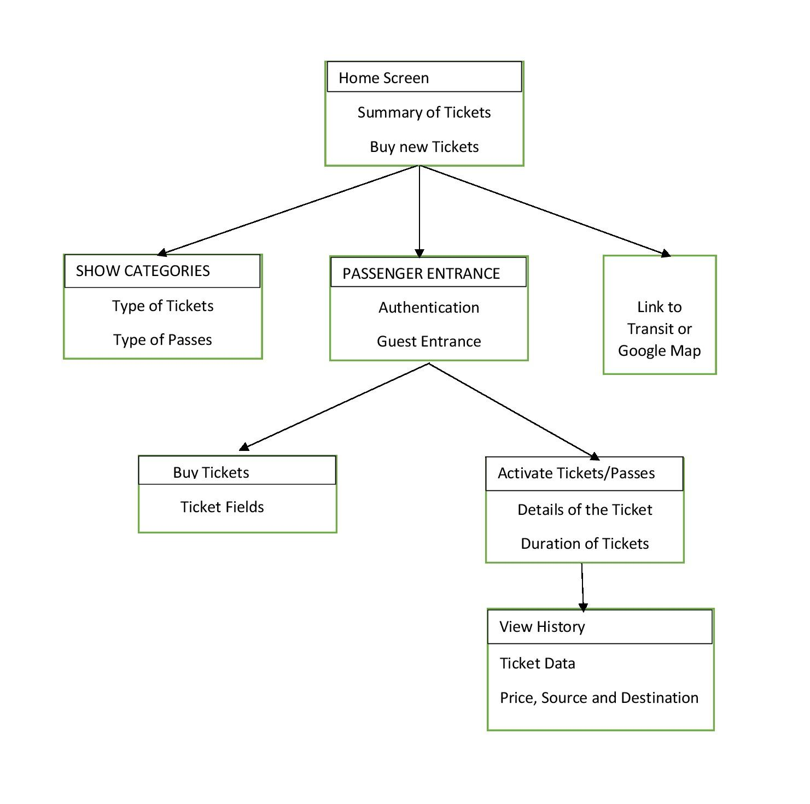

Figure 4: A low-fidelity prototype for passenger.

**Admin Prototype**

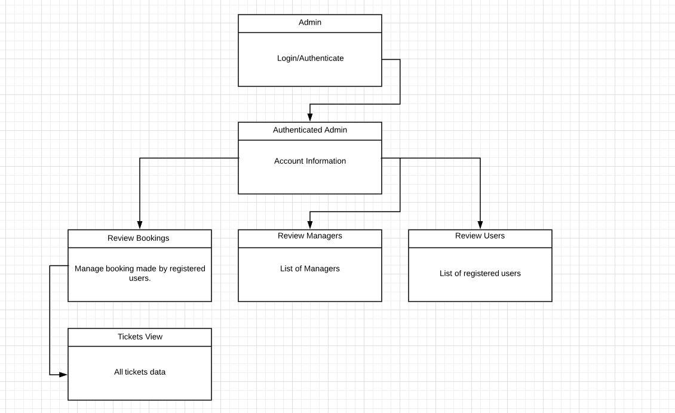

Figure 5: A low-fidelity prototype for admin.

**Manager Prototype:**

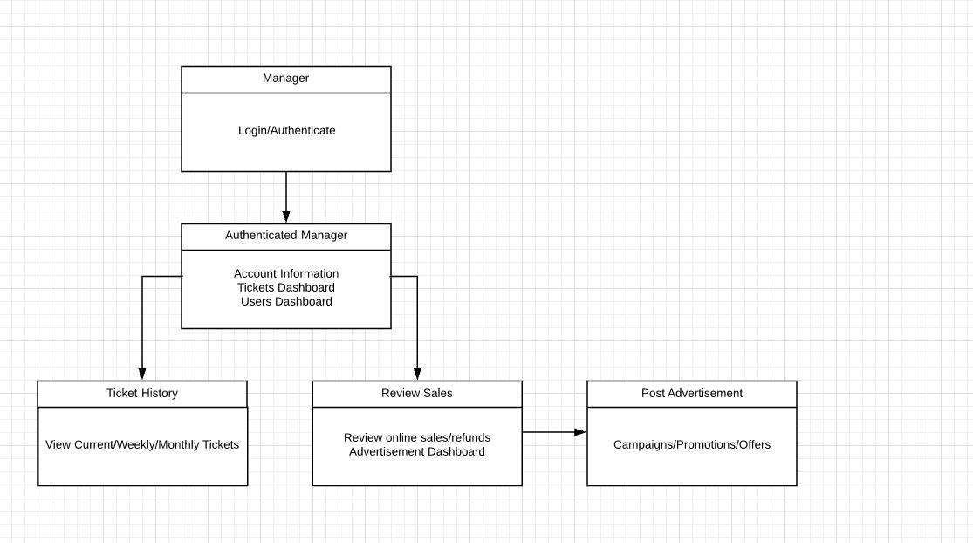

Figure 6: A low-fidelity prototype for manager.

**User Story:**

A user can login as guest or existing user.

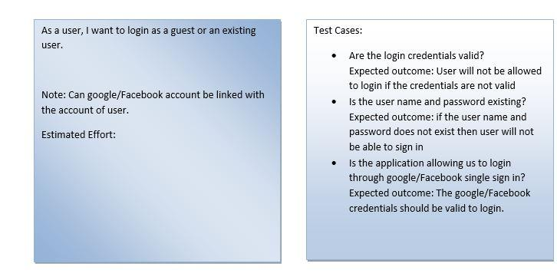

Figure 2.4.1: Representation of login story card.

**User Story:**

User can buy a ticket on or before boarding.

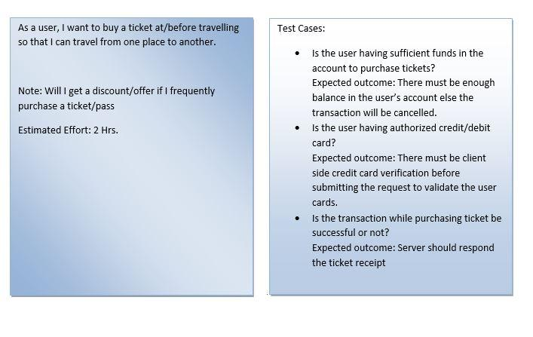

Figure 2.4.2: Representation of ticket purchasing story card.

**User Story :**

User can choose the category of pass or ticket, like adult, student.

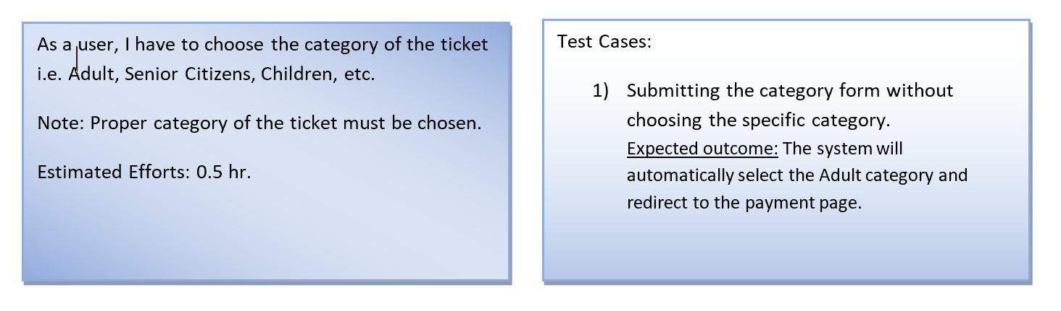

Figure 2.4.3: Representation of choosing a ticket category story card.

**User Story:**

Admin can introduce changes. (i.e.; updates and pricing)

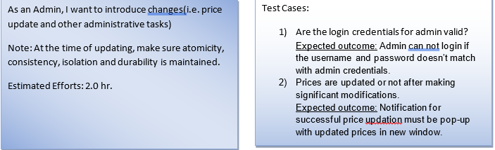

Figure 2.4.4: Representation of introducing changes by admin story card.

**User Story:**

Manager can post offers and changes on the prices.

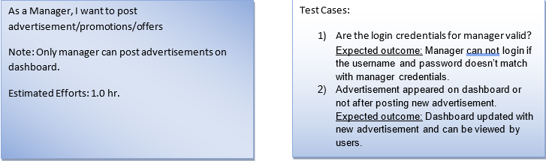

Figure 2.4.5: Representation of posting advertisements by manager story card.

**User Story:**

User can activate the purchased ticket.

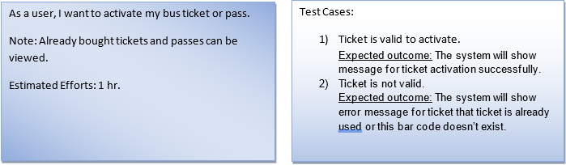

Figure 2.4.6: Representation of activating purchased ticket/pass by user story card.

**User Story:**

User can add/edit or delete the debit or credit card details .

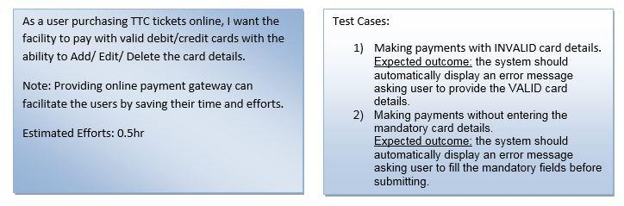

Figure 2.4.7: Representation of Payment Method story card.

**User Story:**

User can view the ticket history.

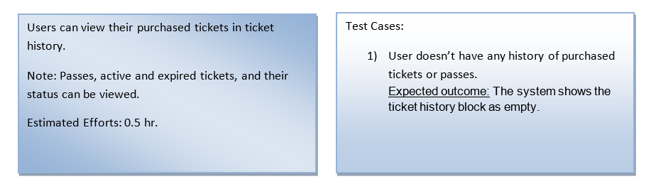

Figure 2.4.8: Representation of viewing ticket history story card.

**User Story:**

As multiple users, we want concurrent access to application without data loss.

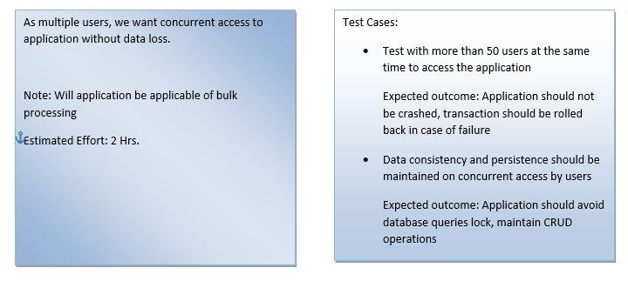

Figure 2.4.9: Representation of concurrent users access story card.

**User Story:**

User can pre-estimate the journey in terms of money, time, and number of tickets.

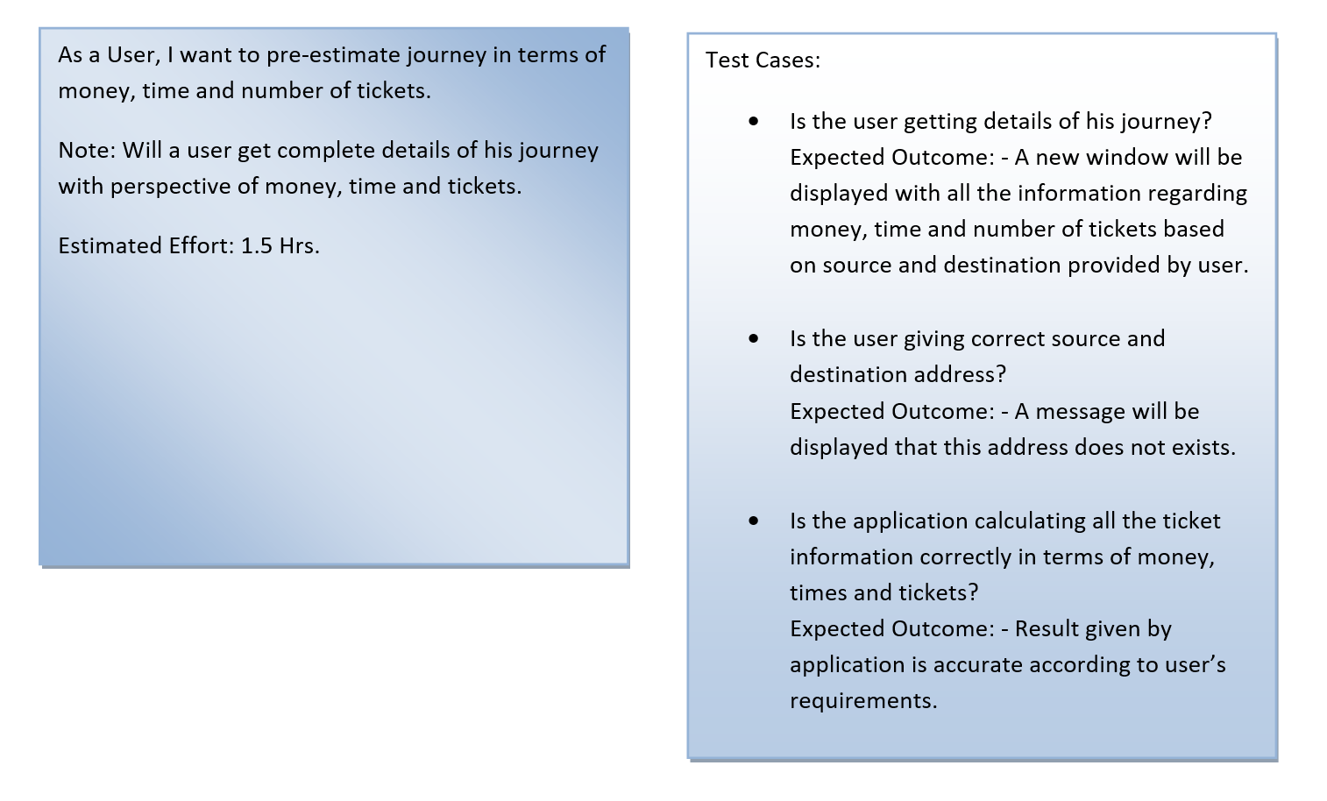

Figure 2.4.10: Representation of pre-estimation of the journey story card.

**User story:**

**User Story:**

User can terminate the ticket.

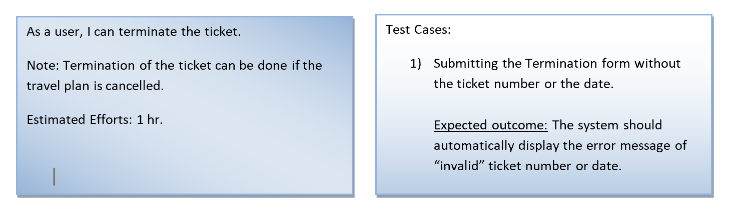

Figure 2.4.11: Representation of termination of the ticket story card.

**User Story:**

User can buy a pass before travelling.

### 

Figure 2.4.12: Representation of purchasing a pass story card.

**User Story:**

User can make a payment in order to buy the pass/ticket.

### 

Figure 2.4.13: Representation of making a payment story card.

**User Story:**

User can select the type of the pass.

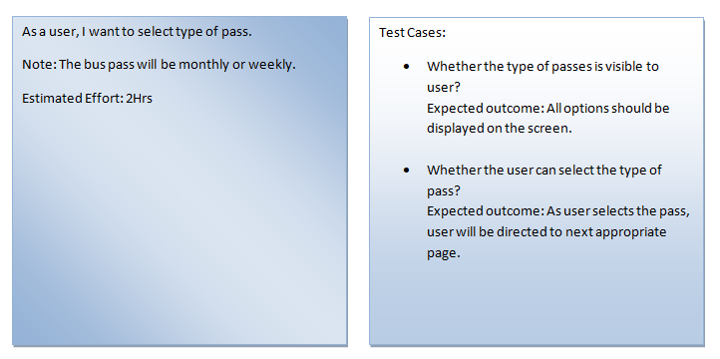

Figure 2.4.14: Representation of selecting pass type story card.

### 2.4.2  Additional Documentation

**Low Fidelity Prototype : Workshop Video Links**

<https://drive.google.com/open?id=1Qne3SKf31sP40Wtlg53yrRkf5Ha9FTZP>

<https://drive.google.com/open?id=1_bIX9NcGE6g_vmjtHuJEvg-GwYkGxn5t>

**2.4.3 Release Plan (1.0)**

**Highest Ranked Prioritized stories**

|  |
| --- |
| **Stories** |
| A user can buy a ticket. |
| A user can buy a pass. |
| A user can Choose Pass Type (monthly or weekly). |
| A user can choose the category of the ticket or pass. |
| A user can add/edit the credit/debit card details |
| A user can make payment. |
| A user can activate the ticket |
| A user can login in the system. |
| User can access menu in application. |
| A User can pre-estimate the journey in terms of money, time, and number of tickets. |
| A User can terminate the ticket. |
| A user can view purchased tickets/passes. |
| A user can view or track the ticket transaction history. |

**MoSCoW Rule:**

Table 1: The **Must-Have** stories for initial Release (1.0).

|  |  |
| --- | --- |
| **Stories** | **Estimate (hrs)** |
| A user can login in the system. | 1.0 |
| A user can buy a ticket. | 1.5 |
| A user can buy a pass. | 1.5 |
| A user can Choose Pass Type (monthly or weekly). | 2.0 |
| A user can choose the category of the ticket or pass. | 1.0 |
| A user can make payment. | 1.5 |
| A user can add/edit the credit/debit card details. | 1.0 |
| A User can pre-estimate the journey in terms of money, time, and number of tickets. | 2.0 |

Table 2: The **Should-Have** stories added to Release (1.0).

|  |  |
| --- | --- |
| **Stories** | **Estimate (hrs)** |
| A user can view purchased tickets/passes. | 1.5 |
| A user can activate the ticket. | 2.5 |
| A user can view or track the ticket transaction history. | 1.5 |
| A User can terminate the ticket. | 1.0 |
| A User will be notified for the ticket expiration. | 1.0 |
| Admin can introduce changes. | 2.0 |
| User can access menu in application. | 2.0 |

Table 3: The **Could-Have** stories

|  |  |
| --- | --- |
| **Stories** | **Estimate (hrs)** |
| A user is notified with the deals/discounts/promotions. | 1.5 |
| A user can delete/edit the profile. | 0.5 |
| A user can change select the language. | 1.5 |

Table 4: The **Won’t-Have** stories

|  |  |
| --- | --- |
| **Stories** | **Estimate (hrs)** |
| Application must be capable of bulk concurrent users access to avoid crashes. | 2.0 |
| A user can provide feedback based on experience. | 1.5 |

**Release Plan Table**

|  |  |
| --- | --- |
| **Iteration 1** | **Iteration 2** |
| A user can access the application either as guest or existing user | A user can make a payment in order to buy the pass/ticket |
| A user can Choose Pass Type (monthly or weekly). | A user can view ticket history. |
| A user can choose the category of the ticket or pass. | A user can activate the ticket. |
| A user can buy a pass. | A user can terminate the ticket. |
| User can access menu in application | A user can add a credit/debit card. |
| A user can buy a ticket |  |

Table 5: Release plan Table

**2.4.4 Iteration Plan (Release 1.0)**

**Iteration 1**

**User Story :** User can access menu in application.

|  |  |  |  |
| --- | --- | --- | --- |
| Task | Who | Estimate | Actual |
| Code basic menu screen | Shiva | 1 hr | 1 hr |
| Code advanced menu screen | Shiva | 2 hrs | 2 hrs |

Table 6: Disaggregated tasks per menu accessing story

**User Story :** A user can buy a ticket.

|  |  |  |  |
| --- | --- | --- | --- |
| Task | Who | Estimate | Actual |
| Code basic ticket buying screen | Sakshi | 1 hr | 2 hrs |
| Code advanced ticket buying screen | Sidharth | 2 hrs | 2 hrs |
| Write and tune SQL queries for buying ticket | Sidharth | 2 hrs | 3 hrs |

Table 7: Disaggregated tasks per buy ticket story

**User Story :**User can buy a pass before travelling.

|  |  |  |  |
| --- | --- | --- | --- |
| Task | Who | Estimate | Actual |
| Code basic pass buying screen | Sidharth | 1 hr | 1 hrs |
| Code advanced pass buying screen | Sidharth | 1 hrs | 2 hrs |
| Write and tune SQL queries for buying pass | Sidharth | 2 hrs | 3 hrs |

Table 8: Disaggregated tasks per buy a pass story

**User Story :** User can choose the category of pass or ticket(i.e: adult, student or senior).

|  |  |  |  |
| --- | --- | --- | --- |
| Task | Who | Estimate | Actual |
| Code basic ticket selection screen | Shiva | 1 hr | 2 hrs |
| Code advanced ticket selection screen | Shiva | 2 hrs | 1 hr |
| Write and tune SQL queries for selecting ticket | Sidharth | 2 hrs | 3 hrs |

Table 9: Disaggregated tasks per choose ticket category

**User Story :** User can select the type of the pass.

|  |  |  |  |
| --- | --- | --- | --- |
| Task | Who | Estimate | Actual |
| Code basic pass selection screen | Manthan | 1 hr | 1 hr |
| Code advanced pass selection screen | Sakshi | 2 hr | 3 hr |
| Write and tune SQL queries for selecting pass | Sidharth | 2 hr | 2 hr |

Table 10: Disaggregated tasks per selection of type of pass story.

**User Story:** The user view the available pass/ticket

|  |  |  |  |
| --- | --- | --- | --- |
| Task | Who | Estimate | Actual |
| Code basic login screen | Sahith | 1 hr | 1 hr |
| Code advanced login screen | Sahith | 1 hr | 2 hr |
| Write and tune SQL queries for user and guest logins | Sahith | 2 hrs | 3 hrs |

Table 11: Disaggregated tasks per viewing of available pass/ticket(s)

**User Story :** A user can access the application either as guest or existing user

|  |  |  |  |
| --- | --- | --- | --- |
| Task | Who | Estimate | Actual |
| Code basic login screen | Deepinder | 1 hr | 1 hr |
| Code advanced login screen | Kiran | 1 hr | 1 hr |
| Write and tune SQL queries for user and guest logins | Kiran | 2 hrs | 3 hrs |

**Iteration 2 : Task tables (In Progress)**

User Story :User can make a payment in order to buy the pass/ticket.

|  |  |  |  |
| --- | --- | --- | --- |
| Task | Who | Estimate | Actual |
| Code basic payment screen | Shiva | 1 hr | 1 hr |
| Code advanced payment screen | Shiva | 2 hrs | 2 hrs |

Table 12: Disaggregated tasks per payment story

User Story:User can activate the purchased ticket.

|  |  |  |  |
| --- | --- | --- | --- |
| Task | Who | Estimate | Actual |
| Code basic ticket activation screen | Sakshi | 1 hr | 2 hrs |
| Code advanced ticket activation screen | Sidharth | 2 hrs | 2 hrs |
| Write and tune SQL queries for activating ticket | Sidharth | 2 hrs | 3 hrs |

Table 13: Disaggregated tasks per ticket activation story.

User Story :User can add/edit or delete the debit or credit card details.

|  |  |  |  |
| --- | --- | --- | --- |
| Task | Who | Estimate | Actual |
| Code basiccard details screen | Sidharth | 1 hr | 2 hrs |
| Code advanced card details screen | Sidharth | 2 hrs | 3 hrs |
| Write and tune SQL queries for card details | Sidharth | 2 hrs | 3 hrs |

Table 14: Disaggregated tasks per add/edit or delete the debit or credit card details story.

User Story :A user can terminate the ticket.

|  |  |  |  |
| --- | --- | --- | --- |
| Task | Who | Estimate | Actual |
| Code basic ticket termination screen | Sahith | 1 hr | 1 hr |
| Code advanced ticket termination screen | Sahith | 1 hr | 2 hr |
| Write and tune SQL queries for ticket termination | Sahith | 1 hrs | 2 hrs |

Table 15: Disaggregated tasks of addition of a credit/debit card story

User Story :User can view ticket history.

|  |  |  |  |
| --- | --- | --- | --- |
| Task | Who | Estimate | Actual |
| Code basic ticket history screen | Deepinder | 1 hr | 1 hr |
| Code advanced ticket history screen | Kiran | 1 hr | 1 hr |
| Write and tune SQL queries for ticket history | Kiran | 2 hrs | 3 hrs |

Table 16 : disaggregated tasks of view ticket history story

### 

### 2.4.5  Progress Monitoring (Iteration 1 & 2)

|  |  |  |
| --- | --- | --- |
|  | Iteration 1 | Iteration 2 |
| Story points at start of iteration | 30 | 20 |
| Completed during iteration | 21 | 16 |
| Changed estimates | 9 | 8 |
| Story points from new stories | 5 | 4 |
| Story points at end of iteration | 39 | 28 |

### 2.4.6 Acceptance tests

|  |  |  |
| --- | --- | --- |
| **Full description of user story** | **Acceptance test(s)** | **Name(s) of contributing Developer(s)** |
| As an User, I will be able to login | User can register with a username and password  Expected outcome:User can successfully register in the application  User can login as a guest  Expected outcome : User can successfully login in the application without entering login details  User can login as registered user  Expected outcome : A user can successfully login using login credentials and use the application | Deepinder  Kiranpreet |
| As a user , I can choose a pass type | User can select the type of the TTC pass i.e monthly or weekly from the pass type list  Expected outcome : User can successfully select the choice and choice is added to cart. | Shiva  Sakshi |
| As an User, I can choose the category of the ticket or pass | A user can choose the ticket category from the list of the available tickets  Expected outcome:The user choice is selected and choice is added to cart  User can select the category of the pass i.e ( Student /Adult/Senior CItizen)  Expected outcome: The user is able to select its choice and add it to cart | Sidharth  Sakshi |
| As an User, I can buy the pass or ticket | User can pay for the selected type of pass or ticket    Expected outcome:the user is able to successfully make a payment for the ticket or pass  User can enter the bank details to proceed the payment  Expected outcome : A user is able to enter valid card detail to validate the payment | Sidharth  Shiva |
| As a user , I can access the menu of the application. | User can view and scroll through the menu of the application and select the choice  Expected outcome: User is able to open the menu and select its choice from the menu items list | Manthan  Deepinder |
| As a user , I can view the ticket history | User can view the list of purchased tickets history.  Expected Outcome : The list of all the purchased tickets can be viewed in the ticket history section. | Sahith  Sidharth |
| As a user , I can activate the ticket | User can click the activate ticket button and the ticket is activated for 2 hrs  Expected outcome : The timer for 2 hrs gets started as the activate ticket button is clicked | Shiva  Kiranpreet |
| As a user , I can terminate the ticket | User can click the terminate ticket button and the ticket gets terminated and is removed from the list of activated tickets  Expected outcome : The tickets gets terminated successfully | Deepinder  Sidharth |
| As a user , I can add the debit and credit card details | User can add the debit or credit card details after selecting the ticket or pass type  Expected outcome : The card details are validated and payment is processed. | Shiva  Sakshi  Sidharth |

### 

### 2.5 Release Plan

### 2 2.5.1 User Stories

**User Story:**

User can provide feedback, based on their experience.

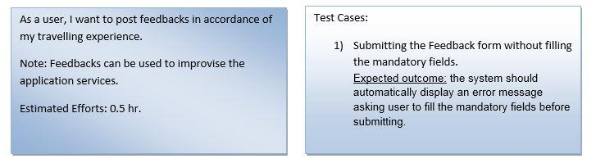

Figure 2.5.1: Representation of Feedback story card.

**User Story:**

User will be notified for the ticket expiration.

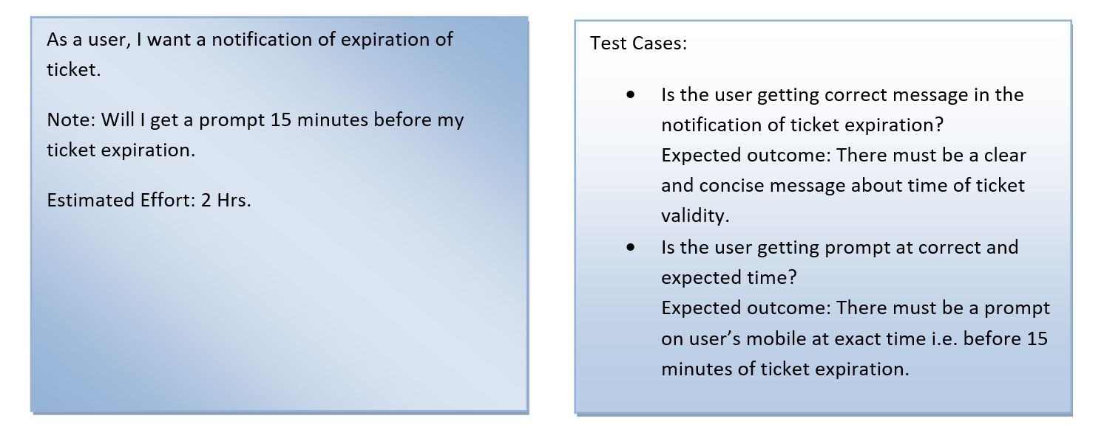

Figure 2.5.2 Representation of ticket expiration story card.

User can edit/delete the profile.

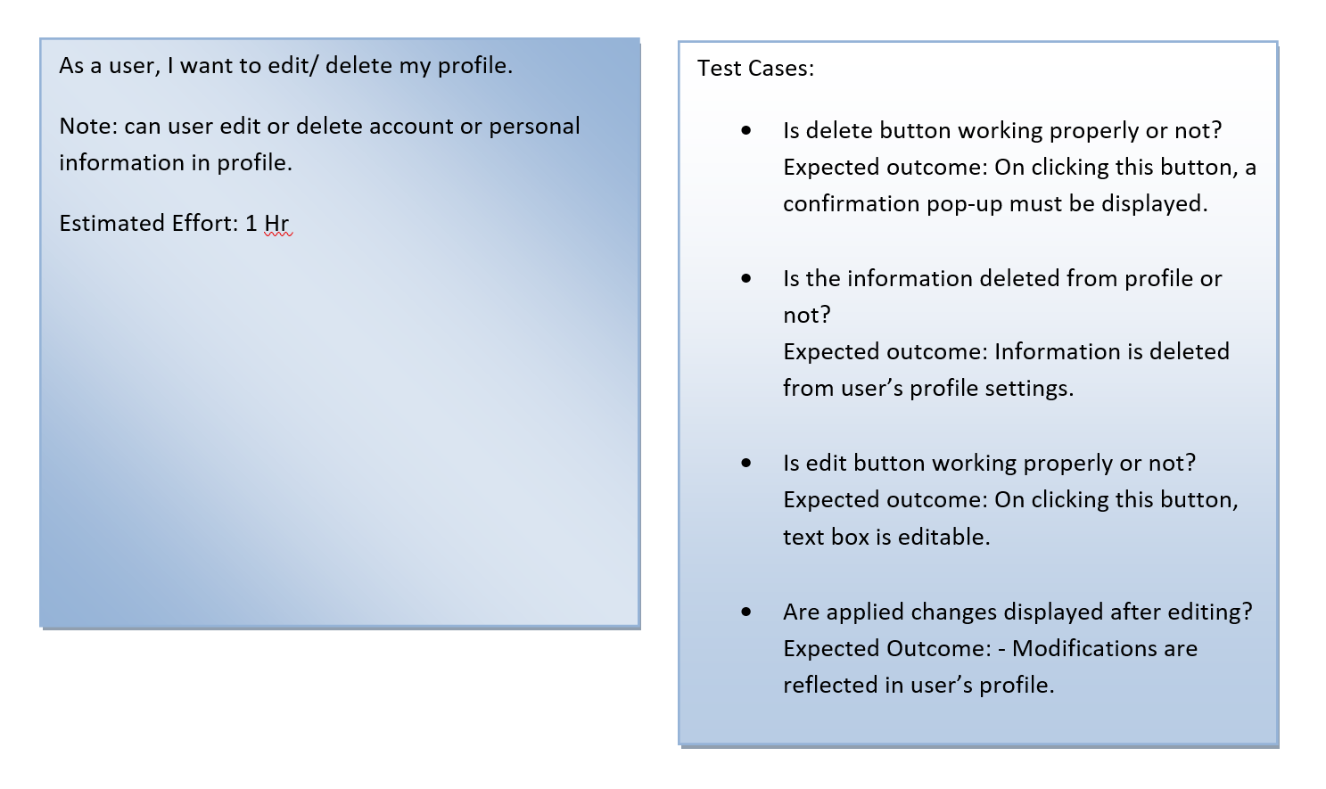

Figure 2.5.3 Representation of editing/deleting the profile story card.

**User Story:**

User can change/select the language.

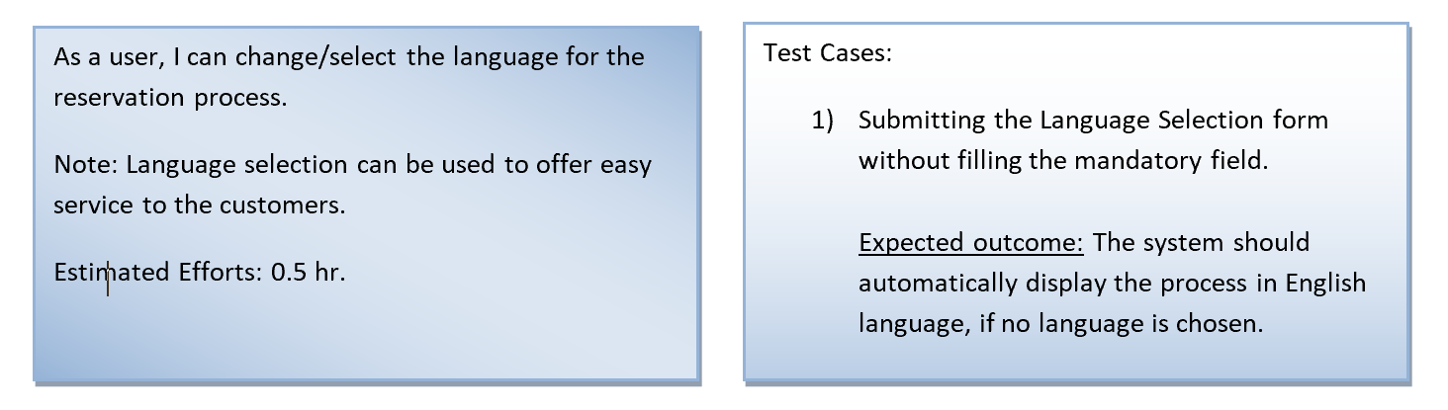

Figure 2.5.4: Representation of changing/selecting language story card.

**User Story:**

User can be notified for promotions/deals/discounts.

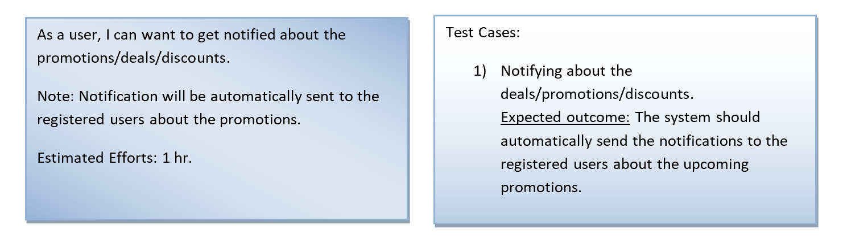

Figure 2.5.5: Representation of notifications regarding promotions story card.

### 2.5.2 Release Plan 2.0

### 

**Highest Ranked Prioritized stories**

|  |
| --- |
| **Stories** |
| Admin can introduce changes. (i.e. updates and pricing) |
| A User can edit/delete the profile. |
| A User can be notified for promotions/deals/discounts. |
| A User can provide feedback based on experience. |
| Admin or Manager can Login to the system. |

Table : 17: Release plan 2 stories list

**MoSCoW Rule:**

Table 18: The **Must-Have** stories for initial Release (2.0).

|  |  |
| --- | --- |
| **Stories** | **Estimate** |
| .Admin can introduce changes. (i.e.; updates and pricing) | 3.5 |
| Manager can post offers and advertisements . | 2 |
| A User can be notified for promotions/deals/discounts. | 1.5 |
| Application must be capable of bulk concurrent users access to avoid crashes. | 2 |

Table 19: The **Should-Have** stories added to Release (2.0).

|  |  |
| --- | --- |
| **Stories** | **Estimate (hrs)** |
| A User will be notified for the ticket expiration | 2 |
| A User can edit/delete the profile. | 2.5 |

Table 20: The **Could-Have** stories

|  |  |
| --- | --- |
| **Stories** | **Estimate (hrs)** |
| A user can provide feedback based on experience. | 2 |
| A User can change/select the language. | 1.5 |

**Release Plan Table**

|  |
| --- |
| **Iteration 3** |
| A User will be notified for the Pass expiration. |
| Admin can introduce changes. (i.e. updates and pricing) |
| A User can edit/delete the profile. |
| A user can provide feedback based on experience. |
| Admin can access users and tickets. |
| Admin can login in the system. |

Table 21: Release 2.0 plan Table

### 2.5.3 Iteration Plan

**Iteration 3 : Task Tables**

|  |  |  |  |
| --- | --- | --- | --- |
| Task | Who | Estimate | Actual |
| Code basic admin login screen | Deepinder | 1 hr | 1 hr |
| Code advanced admin login screen | Kiran | 1 hr | 1 hr |
| Write and tune SQL queries for user and guest logins | Sakshi | 2 hrs | 3 hrs |

Table 22: Disaggregated tasks of admin login story

|  |  |  |  |
| --- | --- | --- | --- |
| Task | Who | Estimate | Actual |
| Code user & ticket accessing screen for Admin | Shiva | 1 hr | 2 hr |
| Write and tune SQL queries for users & tickets access story | Sakshi | 2 hr | 3 hr |

Table 23 : Disaggregated tasks of admin can access users & tickets story

|  |  |  |  |
| --- | --- | --- | --- |
| Task | Who | Estimate | Actual |
| Code basic feedback screen | Shiva | 1 hr | 1 hr |
| Code feedback option in Menu | Shiva | 1 hr | 1 hr |
| Write and tune SQL queries for storing feedback | Shiva | 2 hrs | 2 hrs |

Table 24 : Disaggregated tasks of feedback story

|  |  |  |  |
| --- | --- | --- | --- |
| Task | Who | Estimate | Actual |
| Code basic access screen for admin | Kiran | 1 hr | 1 hr |
| Code price updation screen for admin | Deepinder | 2 hr | 3 hr |
| Write and tune SQL queries for updation | Kiran | 2 hr | 2 hr |

Table 25 : Disaggregated tasks of admin can make changes story

|  |  |  |  |
| --- | --- | --- | --- |
| Task | Who | Estimate | Actual |
| Code basic edit profile screen | Sakshi | 1 hr | 1 hr |
| Code basic delete profile screen | Sidharth | 1 hr | 1 hr |
| Write and tune SQL queries for editing and deleting profile information | Sidharth | 2 hrs | 3 hrs |

Table 26: Disaggregated tasks of editing and deleting profile information story

|  |  |  |  |
| --- | --- | --- | --- |
| Task | Who | Estimate | Actual |
| Code basic notification message on Pass expiration at the End of Month. | Manthan | 1 hr | 1 hr |
| Code basic notification message on Pass expiration through prompt on available passes screen. | Sahith | 1 hr | 2 hr |

Table 27: Disaggregated tasks of notifying User for Pass expiration information story

### 2.5.4 Additional Documentation

Iteration Planning 3 Video Link :

<https://drive.google.com/file/d/1dS8Z1YA693q1NlqdUkqfR-ZRIIm8qutd/view?usp=sharing>

### 2.5.5 Progress Monitoring

|  |  |
| --- | --- |
|  | Iteration 3 |
| Story points at start of iteration | 22 |
| Completed during iteration | 18 |
| Changed estimates | 7 |
| Story points from new stories | 3 |
| Story points at end of iteration | 28 |

### Table 28 :Progress and changes for all Iterations for Release 2.0

### 2.5.6 Acceptance tests

|  |  |  |
| --- | --- | --- |
| **Full description of user story** | **Acceptance test(s)** | **Name(s) of contributing Developer(s)** |
| As an User, I will be notified of pass expiration | User gets a prompt at 1 hr 45 minutes after the ticket being activated.  Expected outcome:User gets a prompt of ticket expiration | Manthan |
| As an Administrator, I can update the prices of the tickets and passes | Admin can update the enter the updated price in price updation screen  Expected outcome: Price updation successful prompt and price gets updated in application | Deepinder ,  Kiranpreet |
| As an User, I can edit or delete the profile | A user can choose to delete the user profile by selection delete profile button  Expected outcome: User profile gets deleted  User can edit the profile details  Expected outcome: The user details should be updated in the application. | Sidharth  Sakshi |
| As an User, I can provide feedback based on the user experience | User can enter its comments in the feedback screen  Expected outcome: The user comments should be updated and user should get a prompt that feedback has been submitted | Shiva |
| As an Admin , I can access users and tickets | Admin can view and access all the users of the application  Expected outcome: Admin can access and view the profile information of the guest and registered users  Admin can view tickets price and update the prices  Expected outcome:The list of the ticket price can be viewed by the admin and price can be updated on price updation screen | Sidharth  Shiva  Sakshi |
| As an Admin , I can login in the system | Admin logins with a username and password  Expected Outcome : user is successfully able to login and use the application | Sidharth  Shiva |

Table 29: Acceptance tests for Release 2.0

**3.0 Conclusion**

The delivered prototype demonstrates that TTCPay Application provides a user friendly interface to buy the TTC bus tickets and passes online by providing convenience to the passengers.The application uses an android platform for the implementation. The systems comprised of many subsystems which included Registration subsystem , payment subsystem , feedback subsystem and ticket and pass selection subsystem.All the subsystems were tested by testing the functional aspects separately and then testing the entire system as a complete unit.

The TTCPay application provides a quality of service and good platform to the people for purchasing tickets with ease. The future implementations may include features such as providing payment gateway to the system and providing travel pre-estimation to the passenger.Including other features in the application , elevates the chances of this application to be sustainable.

**APPENDIX A**

**Paper Prototype:**

**Iteration 1:**

User Story: A user can buy a ticket by selecting the buy ticket button and furthermore can select a category.

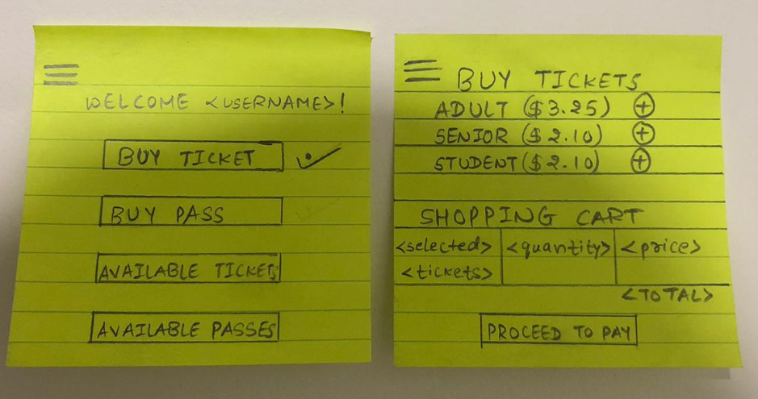

Figure 1: A user can buy a ticket.

User Story: A user can buy a pass by selecting the buy pass button and furthermore can select a category.

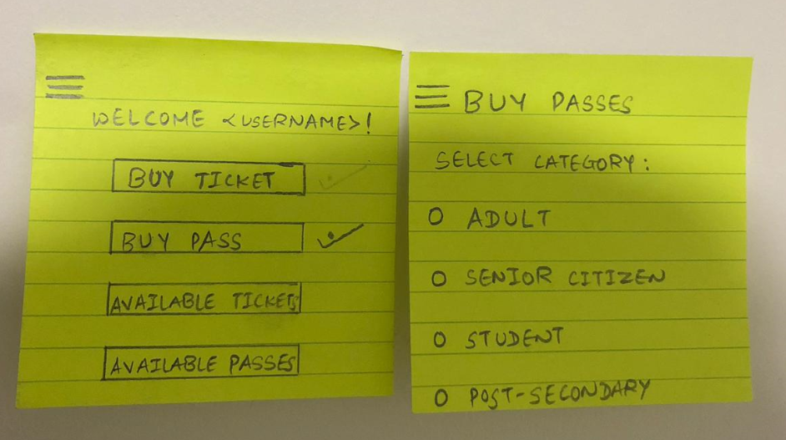

Figure 2: A user can buy a pass.

User Story: A user can select the type of the pass from mentioned 3 categories i.e. Daily, Weekly, or Monthly.

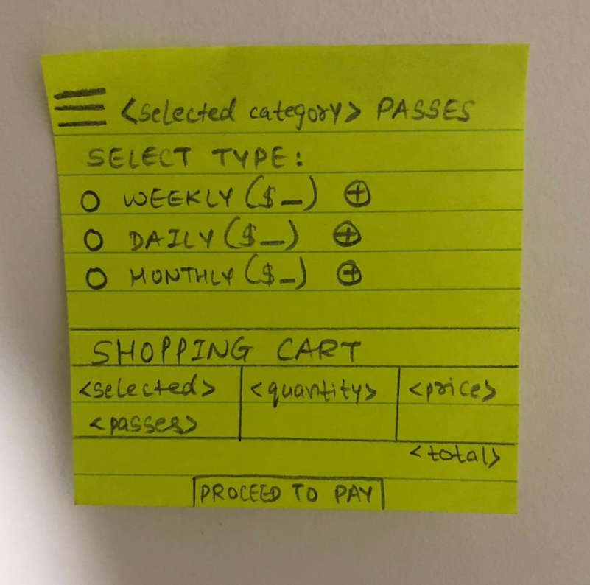

Figure 3: A user can choose the category for the pass.

User Story: A user can choose the category of the ticket from the mentioned 3 categories i.e. Adult, Senior Citizens, or Student.

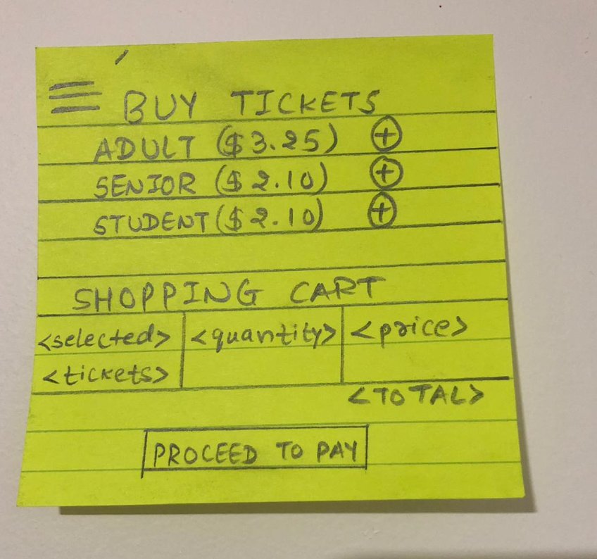

Figure.4: A user can choose the category for the ticket.

User story: A user can directly login if has an account, or else need to create an account to buy tickets or passes.

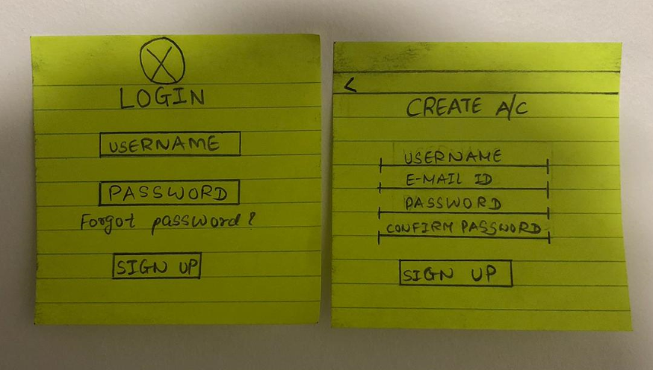

Figure 5 A user can login in the system.

**Iteration 2: Paper prototype**

User story: A user can make payment.

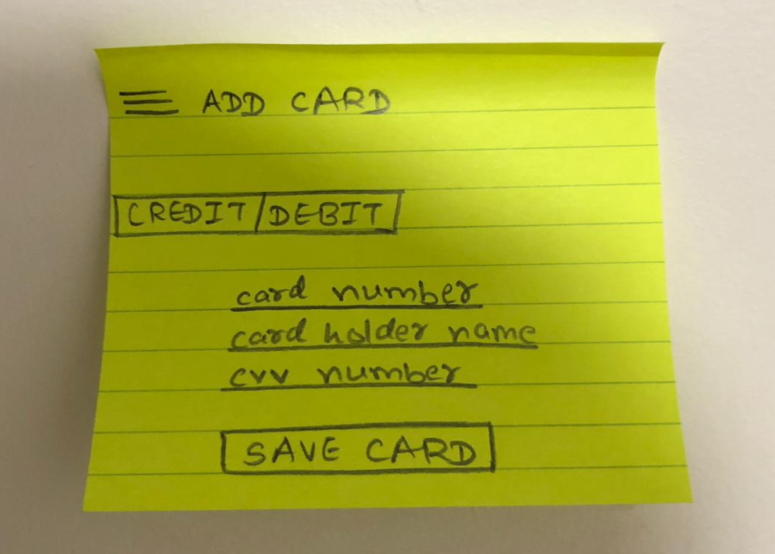

Figure 2.4.3.1: A user can make payment.

User Story: A user can add a credit/debit card.

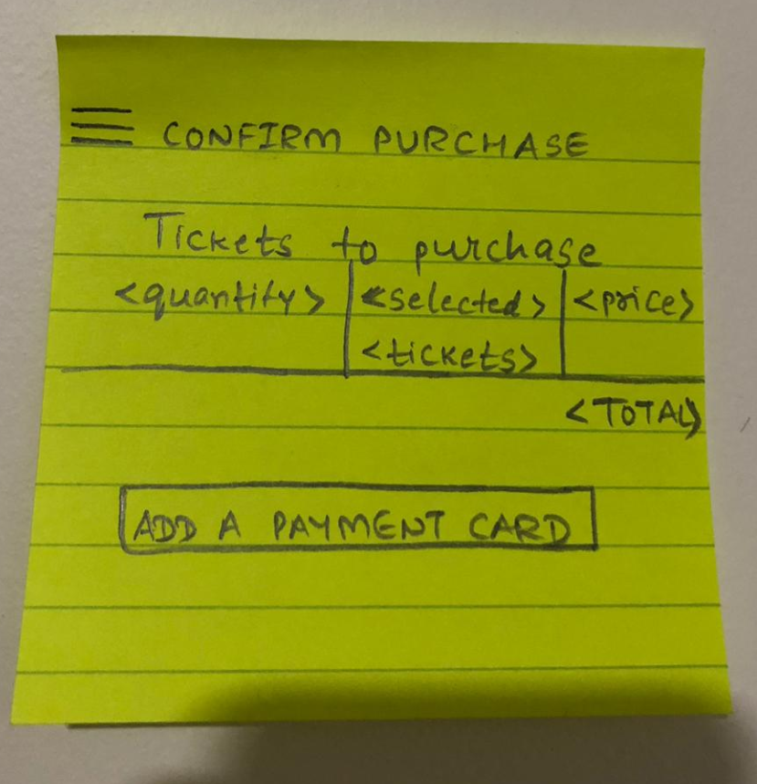

Figure 6: A user can add a credit/debit card.

User Story: User can view the ticket history.

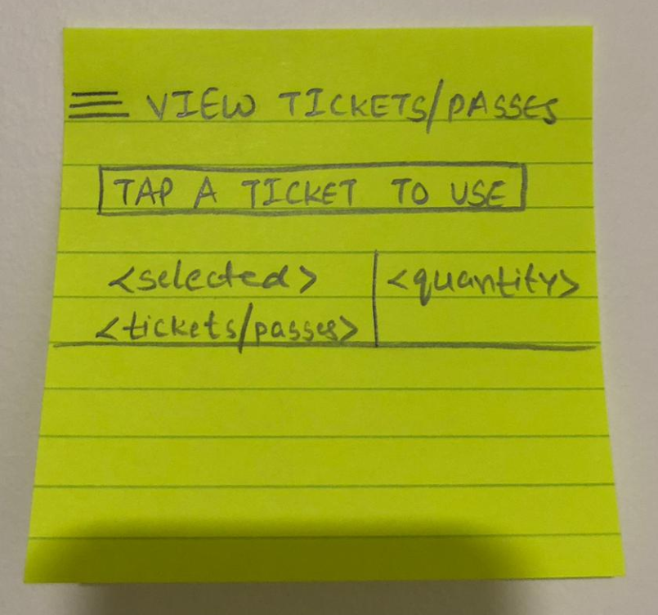

Figure 2.4.3.3: A user can view purchased tickets/passes.

User Story: User can activate the ticket..

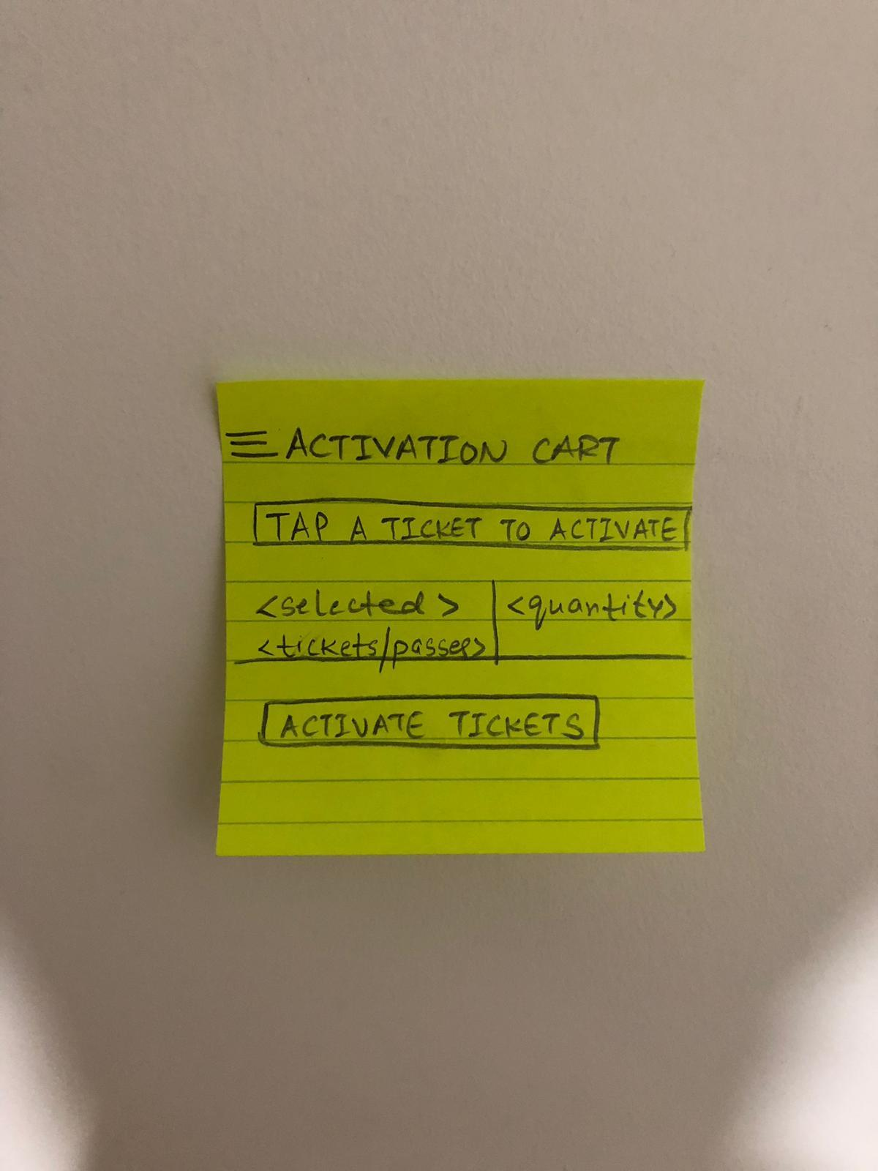

Figure 7: A user can activate the ticket.

**APPENDIX B**

## 1.0 Introduction

### 1.0.1   Goals

The testing goals of the project include proper and user friendly application access to the users and the administrators . Testing all the minor and major functionalities of the application to ensure smooth running of the application. Testing ensures that all the requirements of the project are met . Our team focuses on testing the functional aspects of the application and later on testing the system as a collective unit. The procedure includes testing the functionality and finding the errors in order to resolve them.

### 1.0.2   Risks And Assets

The following risks are included with the TTCPay application:

1. The availability of the internet for a smooth access to the application.
2. Availability of latest android version on user’s phone for an easy access to the application.
3. User can buy at most 20 tickets at a time on the application.

## 2.0 Scope

### 2.0.1   Features To Be Tested

**Functional and non-functional requirements**

The features and functions that will be tested during the project are:

1. The user must be able to login in the system as a guest or as a registered user.
2. A user must be able to select the pass or ticket types from the list provided in the application.
3. The user must be able to make the payment for the ticket or pass selected.
4. The user will be able to view the ticket history which he has bought in the past.
5. The ticket or the pass purchased can be activated and terminated as required.
6. The admin is able to view all the information of the registered users.
7. The administrator is able to update the prices and information of the tickets and passes that are available on the application.
8. The system is able to handle bulk processing with multiple concurrent users accessing the application.

## 3.0 Testing Procedures

Our team focuses on testing the functional aspects of the application and later on testing the system as a collective unit. The testing strategy applied by our team is the Integration testing strategy.The procedure includes testing the functionality and finding the errors in order to resolve them.

### 3.0.1   Test Objectives

The testing objective of the project includes finding and resolving the errors which are generated while the development of the project. Testing ensures that the requirements meet the end product result. The quality of the product is ensured by performing tests on different functionalities of the application.

### 3.0.2   Types Of Testing

Describe the types of testing that the project will use.

#### 3.0.2.1   Unit Testing

The sub systems for the unit tests include :

1. User Login subsystem
2. Ticket or pass selection subsystem
3. Ticket or pass payment subsystem
4. Ticket history subsystem
5. Feedback reporting subsystem

#### 3.0.2.2   Integration Testing

The integration testing strategy include the interaction between different subsystems. The interaction between subsystems in our project is as follows:

1. The user must be able to login in the system in order to perform various tasks such as selecting tickets and purchasing tickets.
2. The user must be able to select the type of pass or ticket in order to pay for the selections.
3. After the successful payment of the selected tickets or the passes , the user must be able to view the purchased tickets/passes in the ticket history subsystem.

#### 3.0.2.3   Acceptance Testing

The acceptance testing of the system involves :

1. The user must be able to login in the application with valid login credentials.
2. Then the user must be able to select the choice of the pass or the ticket.
3. The user must be able to make a successful payment for the choice.
4. The user must be able to view the ticket history details.
5. The user must be able to provide feedback of the experience.

#### 3.0.2.4   Stress Testing

## Our application must be able to run on an android platform with android version 4.4 or above.

1. A single user can purchase upto 20 tickets in the application at a time.
2. 1 GB ram for emulator or 1 GB RAM for device
3. Wifi or internet support
4. Device must be able to receive messages and notification
5. Minimum 2.4 GHZ quad core processor
6. Device must be supportable to at least Marshmallows API 27 version.

## 4.0 Schedule and Deliverables

**Test Result Table :**

|  |  |  |  |  |
| --- | --- | --- | --- | --- |
| **Test Cycle** | **Total test cases** | **Test cases executed** | **Test cases passed** | **Test cases failed** |
| **Cycle 1** | **9** | **9** | **7** | **2** |
| **Cycle 2** | **13** | **13** | **9** | **4** |

**Test Summary Report :**

|  |  |
| --- | --- |
| **Test Type** | **Acceptance testing** |
| Test cases passed | 19 |
| Test cases failed | 5 |
| Total | 24 |

|  |  |
| --- | --- |
| **Test Type** | **Integration testing** |
| Test cases passed | 8 |
| Test cases failed | 2 |
| Total | 10 |

**Appendix C**

**Screenshots of all the user stories :**

**User Story :** A user can access the application either as guest or existing user

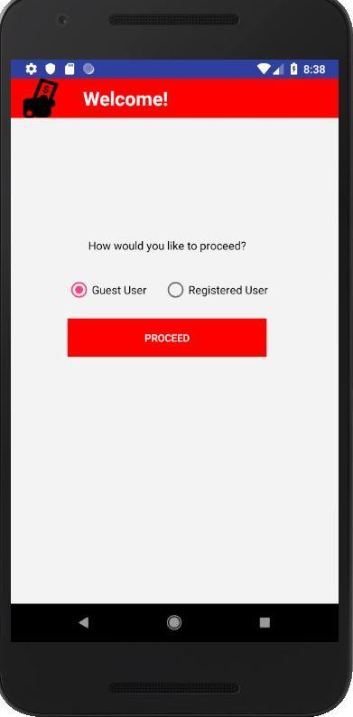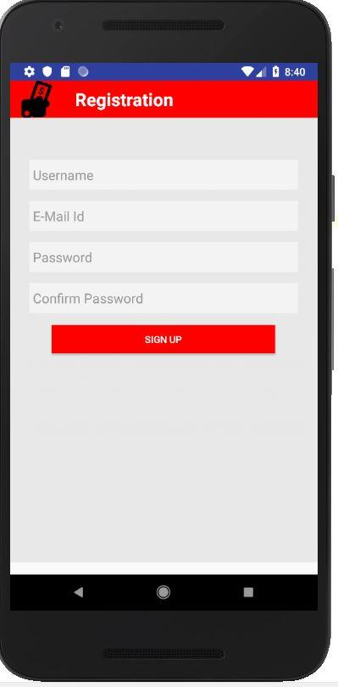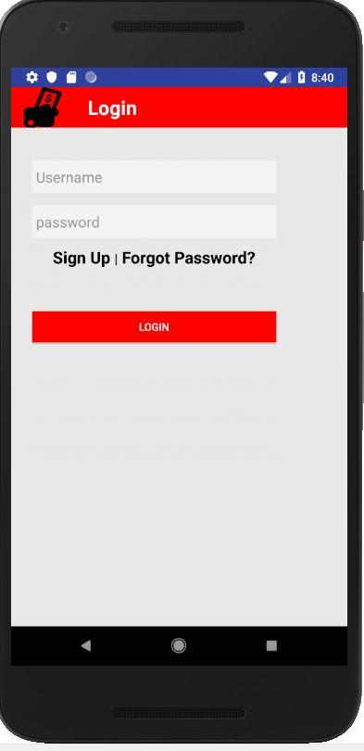

**User Story :** User can access menu in application.

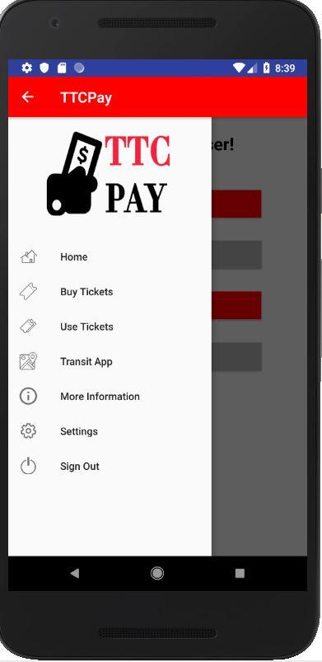

**User Story :** User can choose the category of ticket(i.e: adult, student or senior).

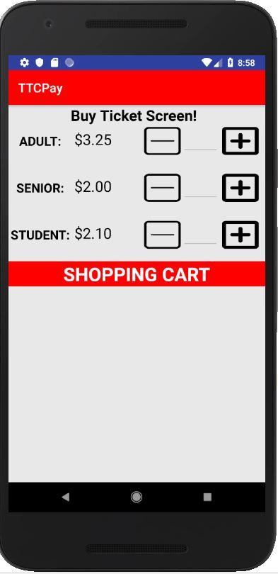

**User Story :** User can select the type of the pass.

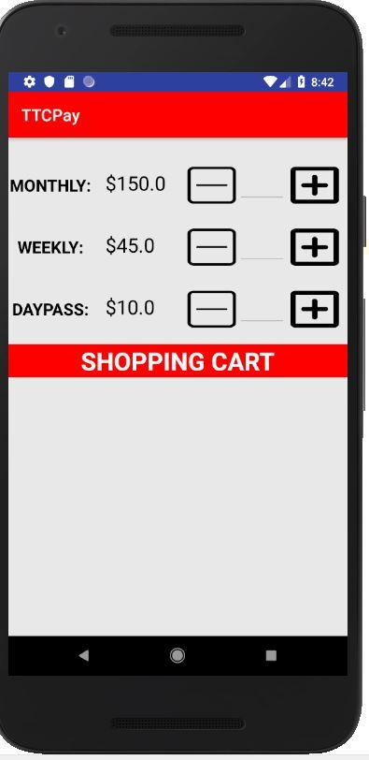

**User Story :**User can buy a pass before travelling.

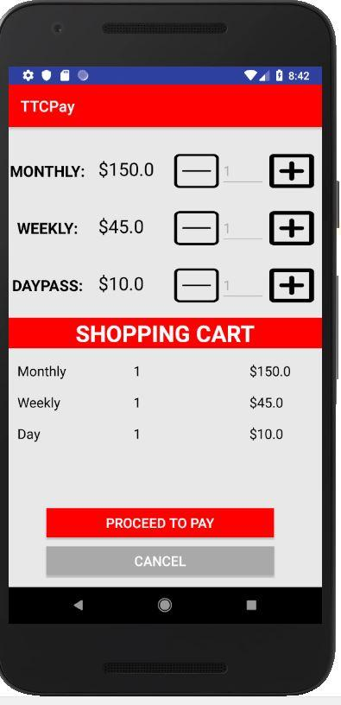

**User Story :** A user can buy a ticket.

